Download:

<https://www.jenkins.io/download/>

Go to -> LTS -> Windows

Finally downloaded Jenkins.msi file.

Installation:

<https://www.youtube.com/watch?v=1y8RsUbxtAw&ab_channel=TravelsCode>

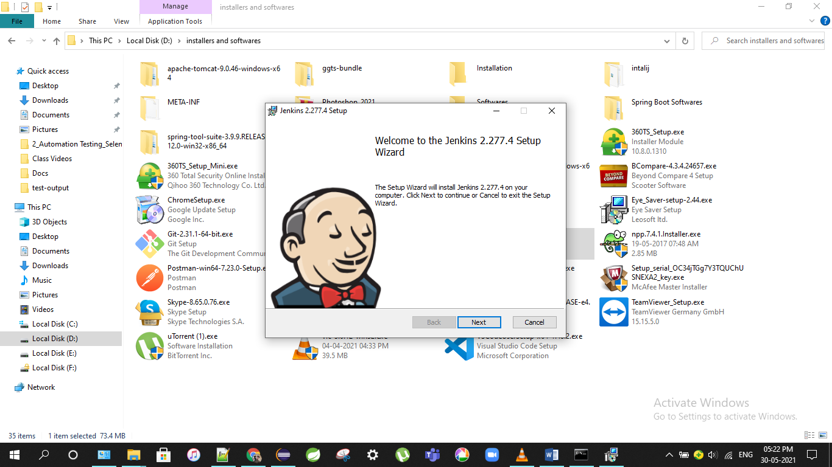

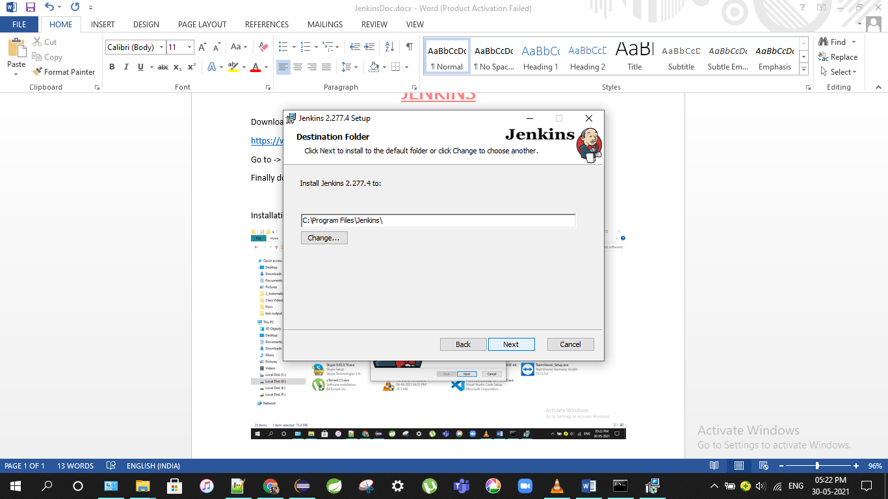

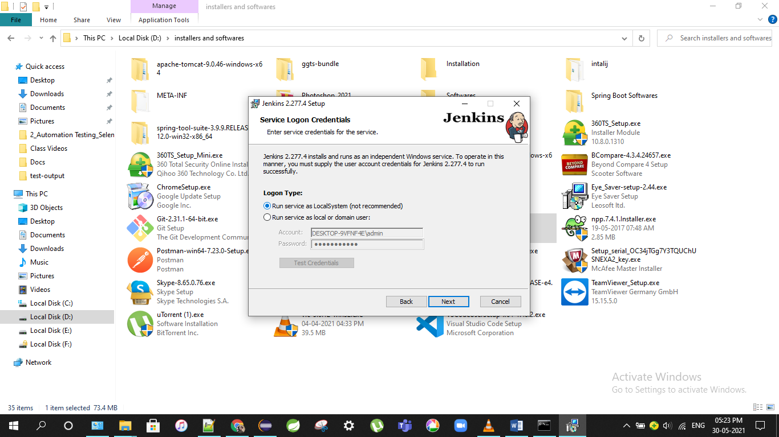

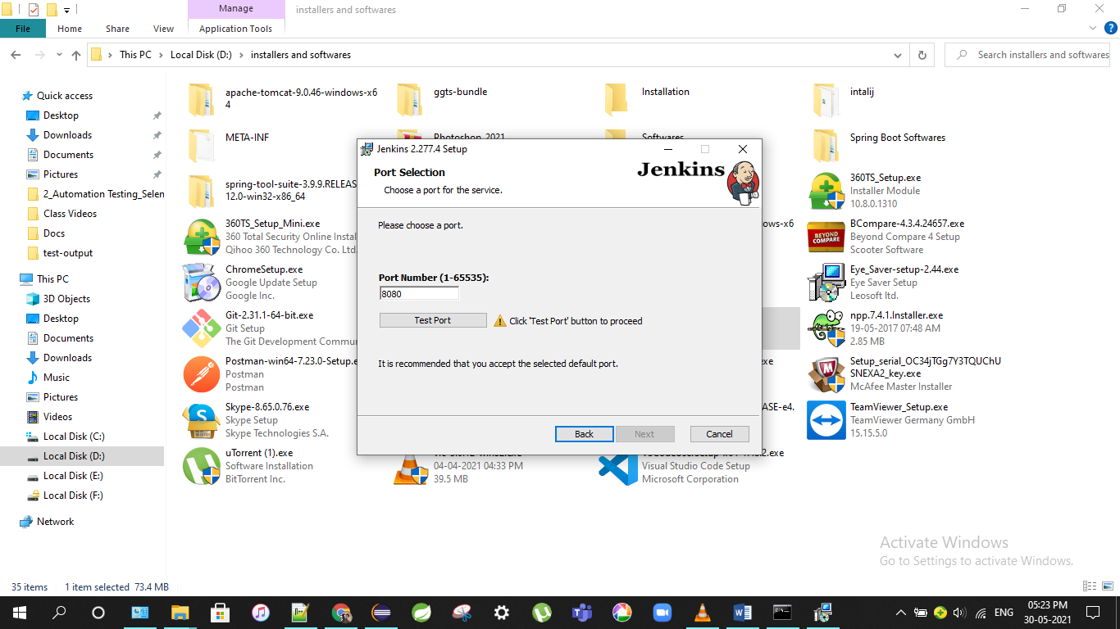

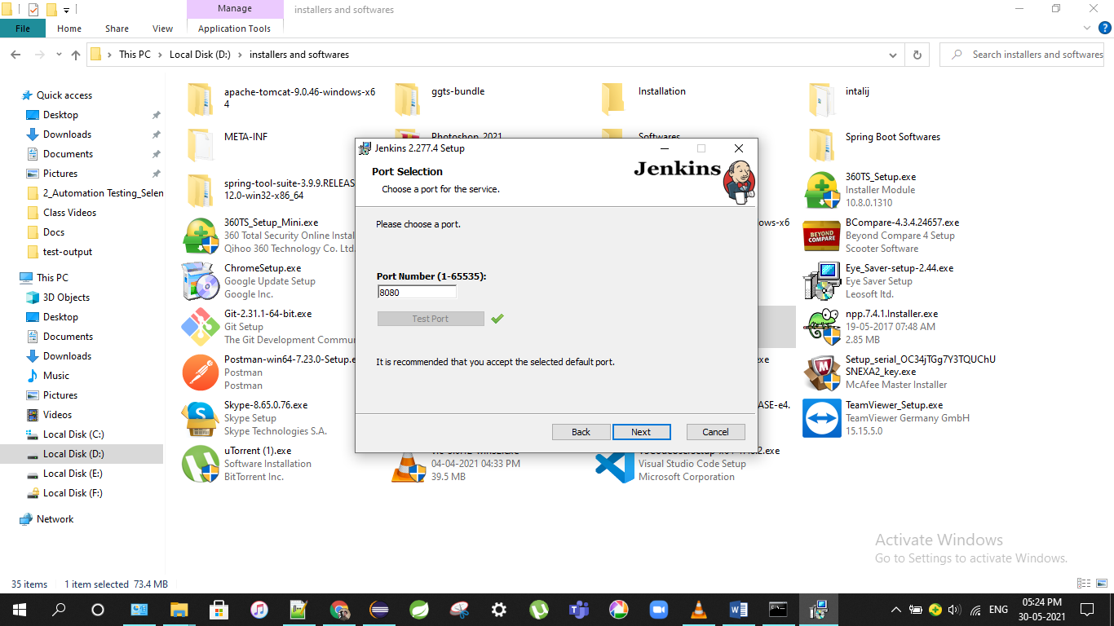

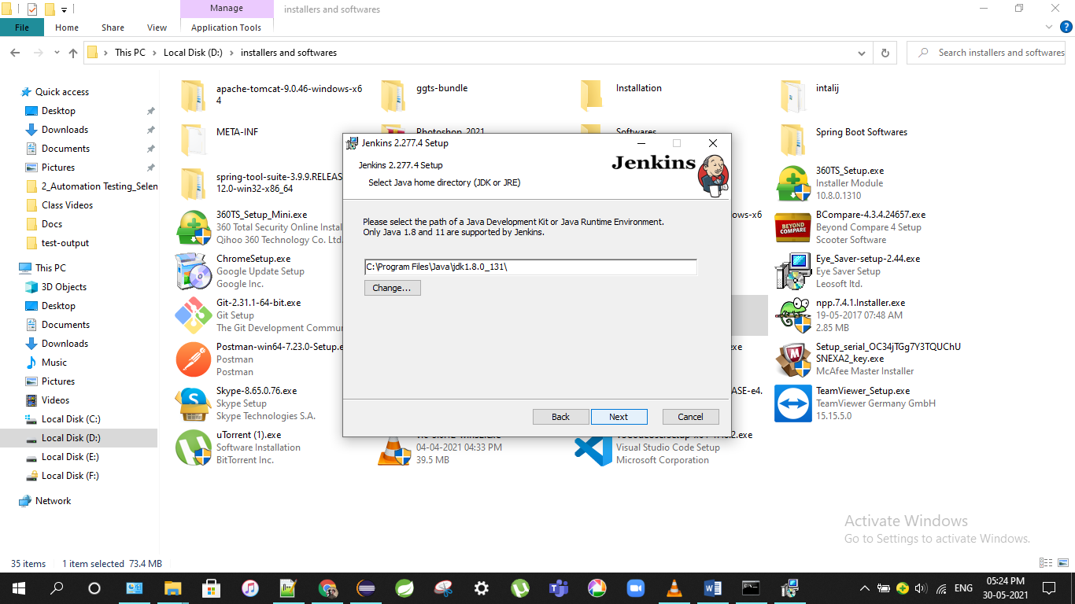

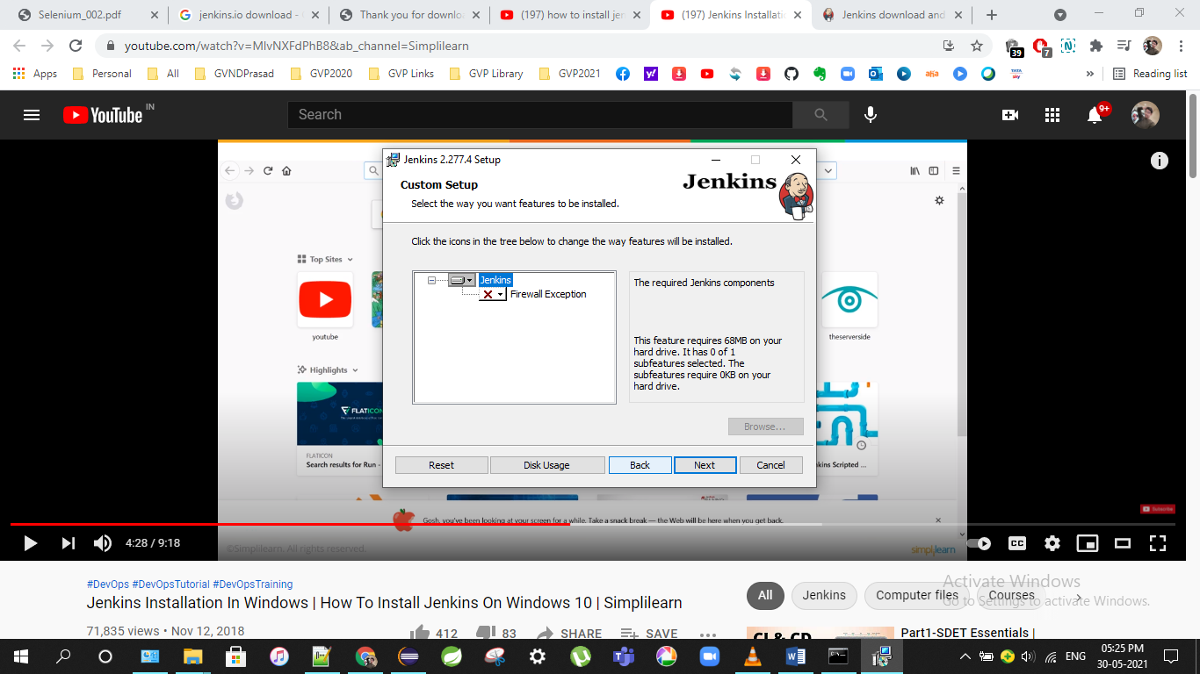

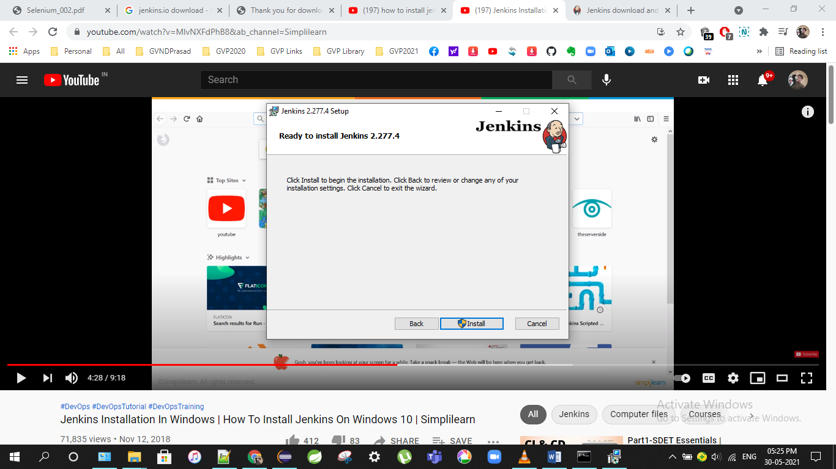

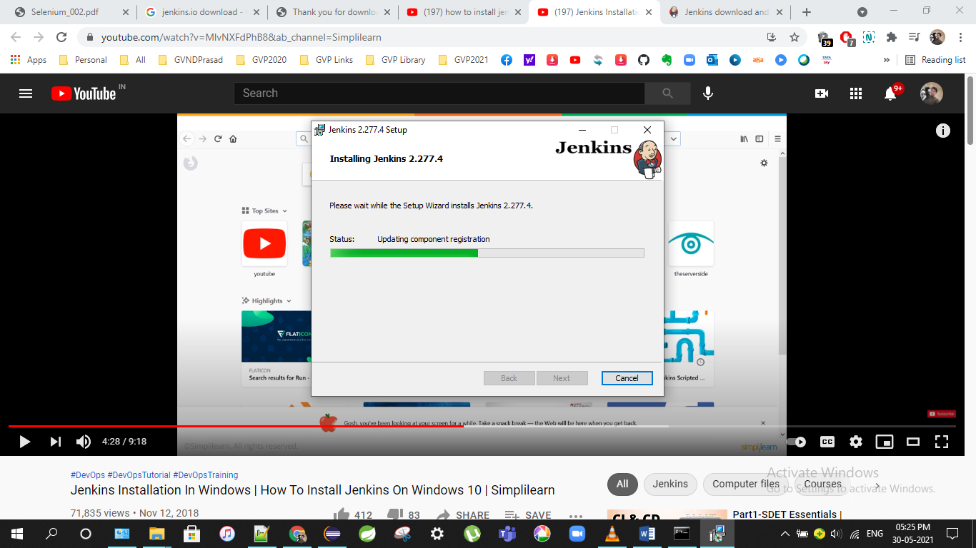

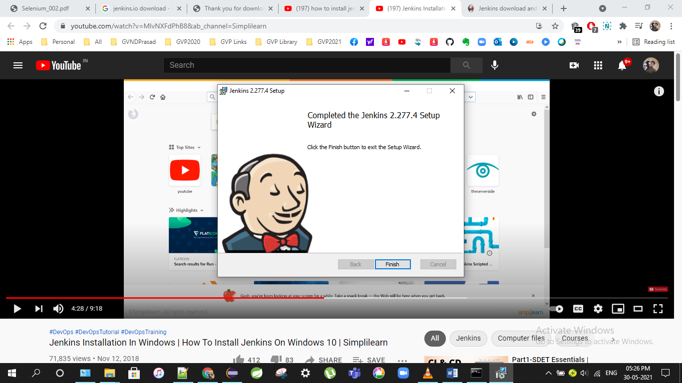

Once completed jenkis automatically starts with port no 8080

<http://localhost:8080/login?from=%2F>

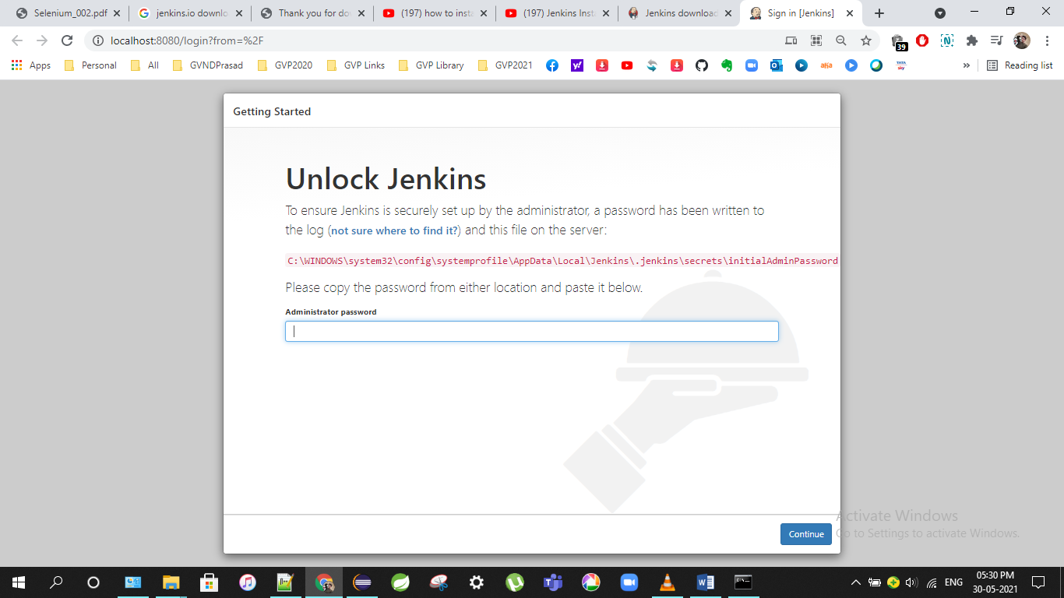

Get the password form given path in your machine

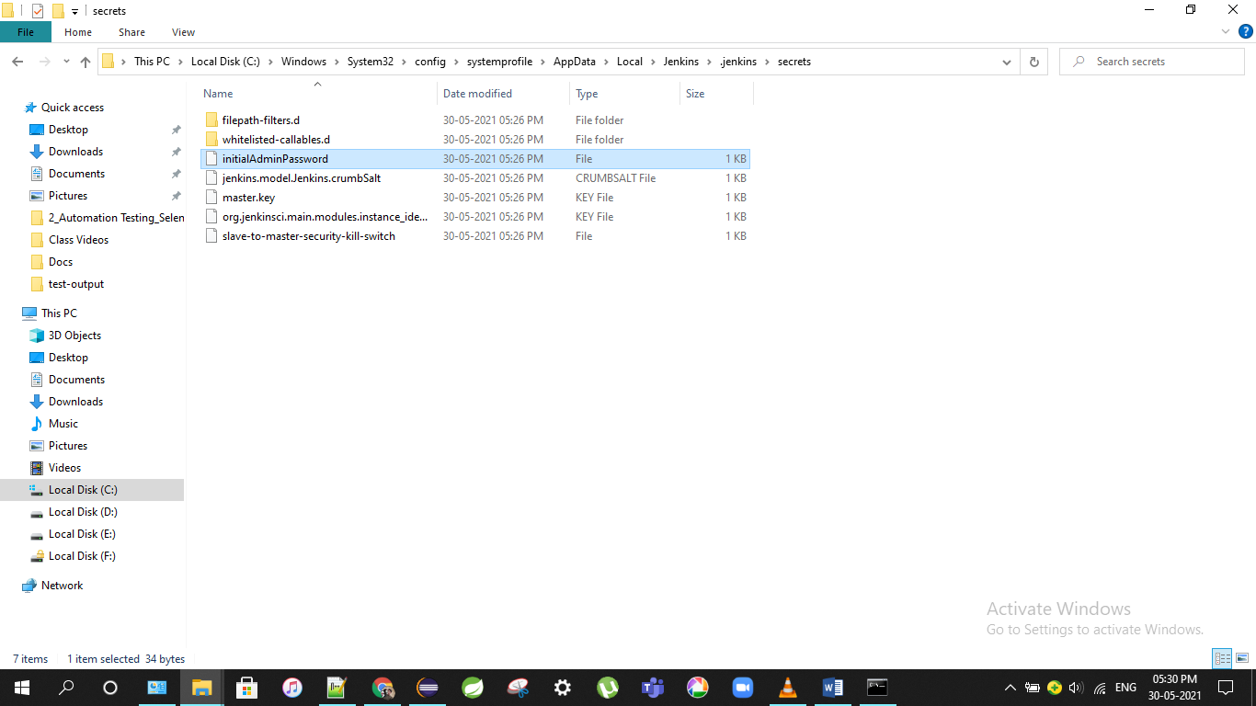

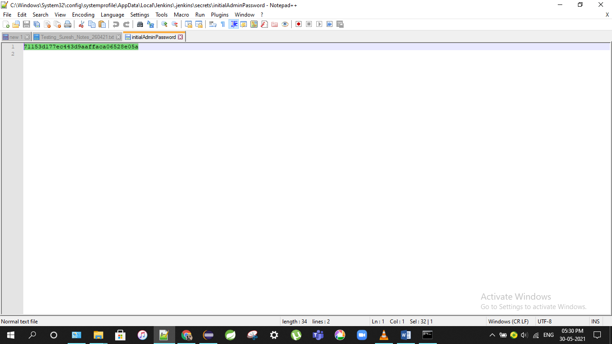

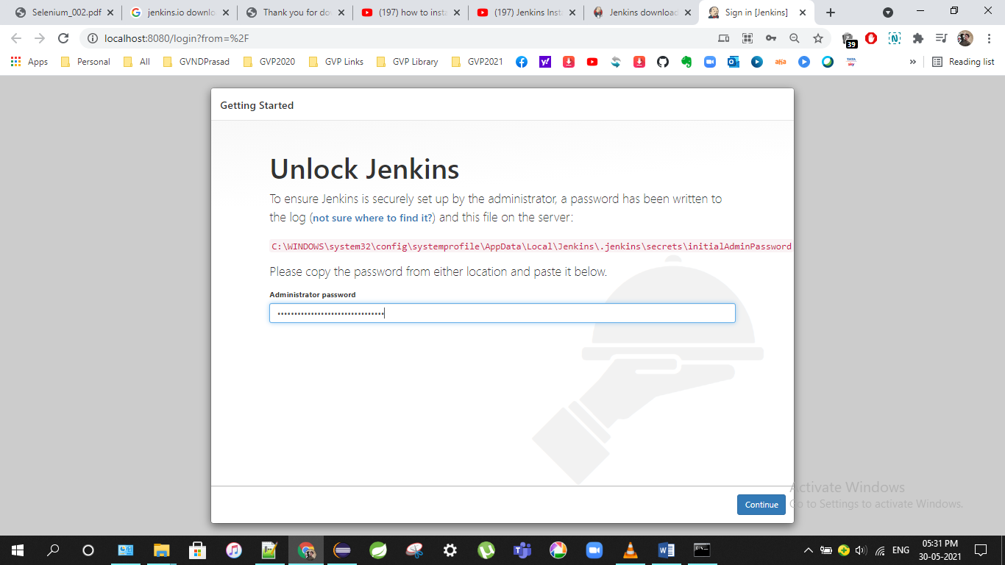

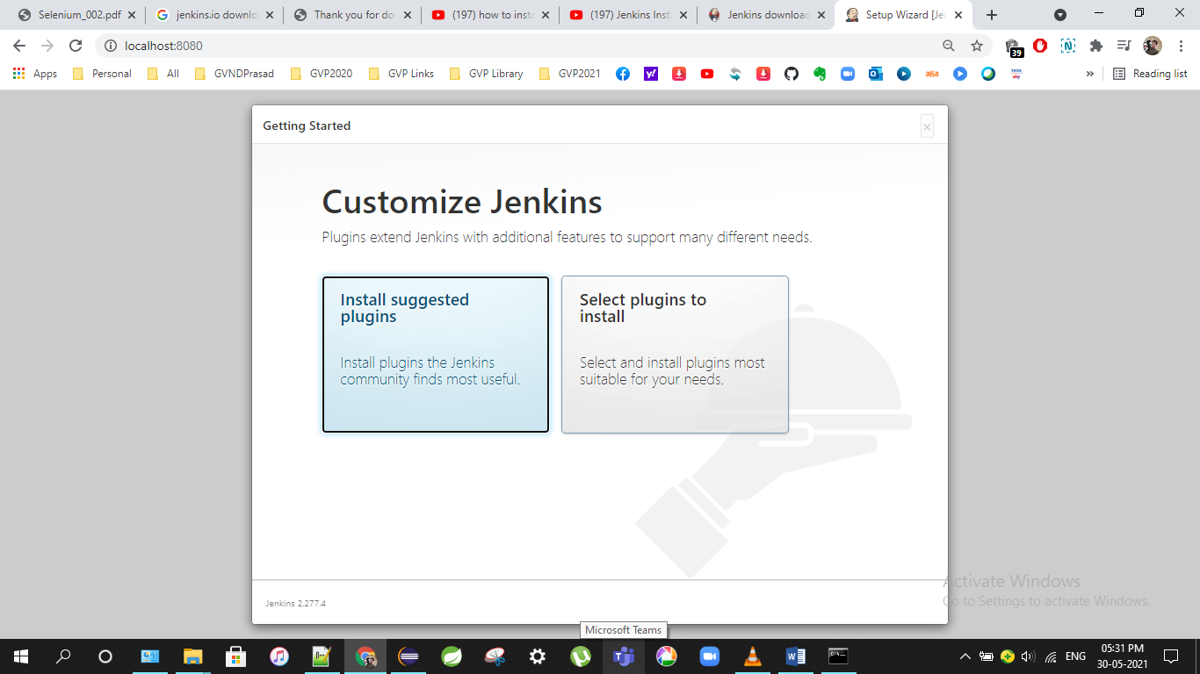

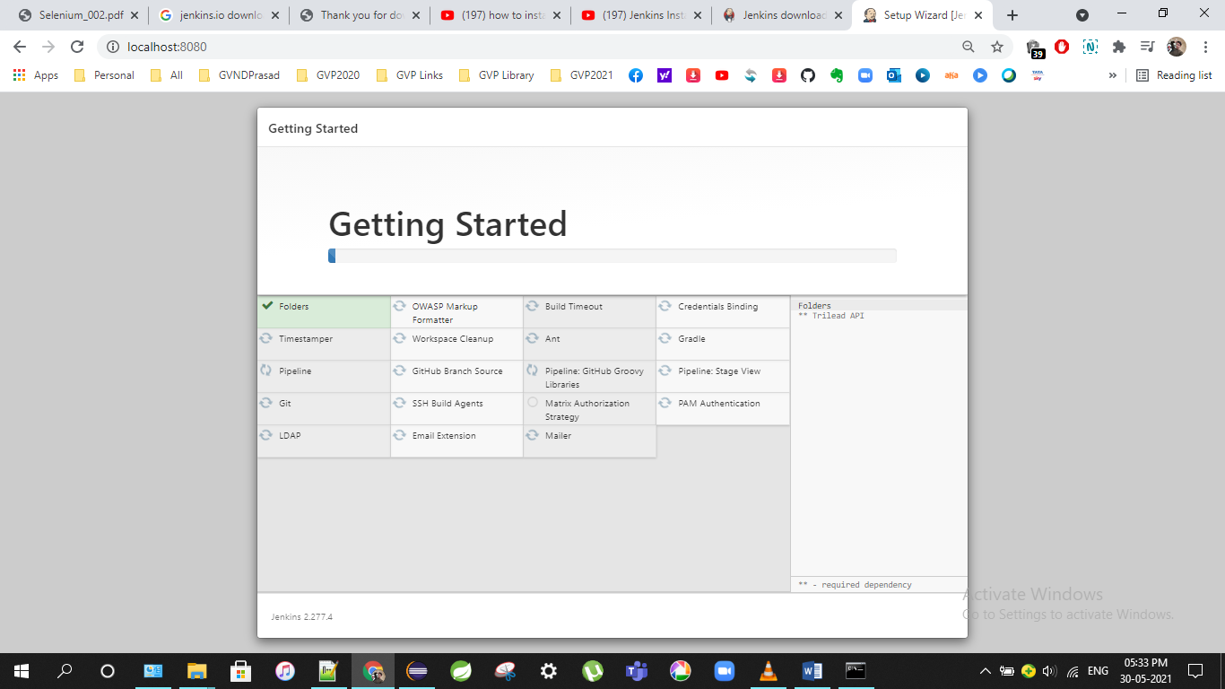

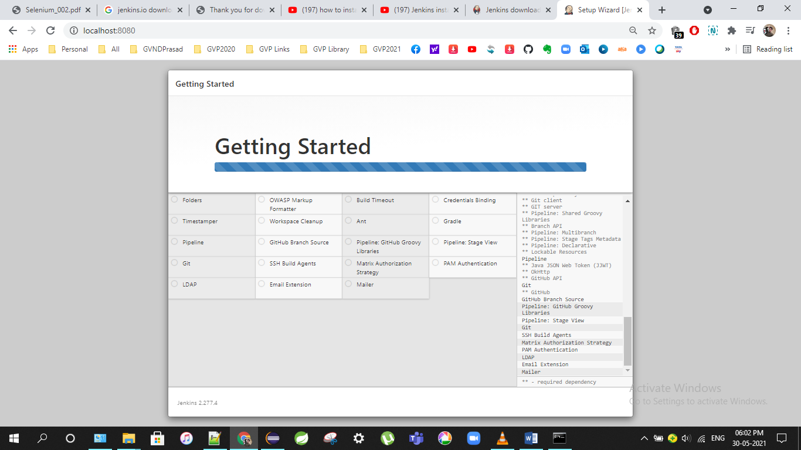

Done all it takes 30min.

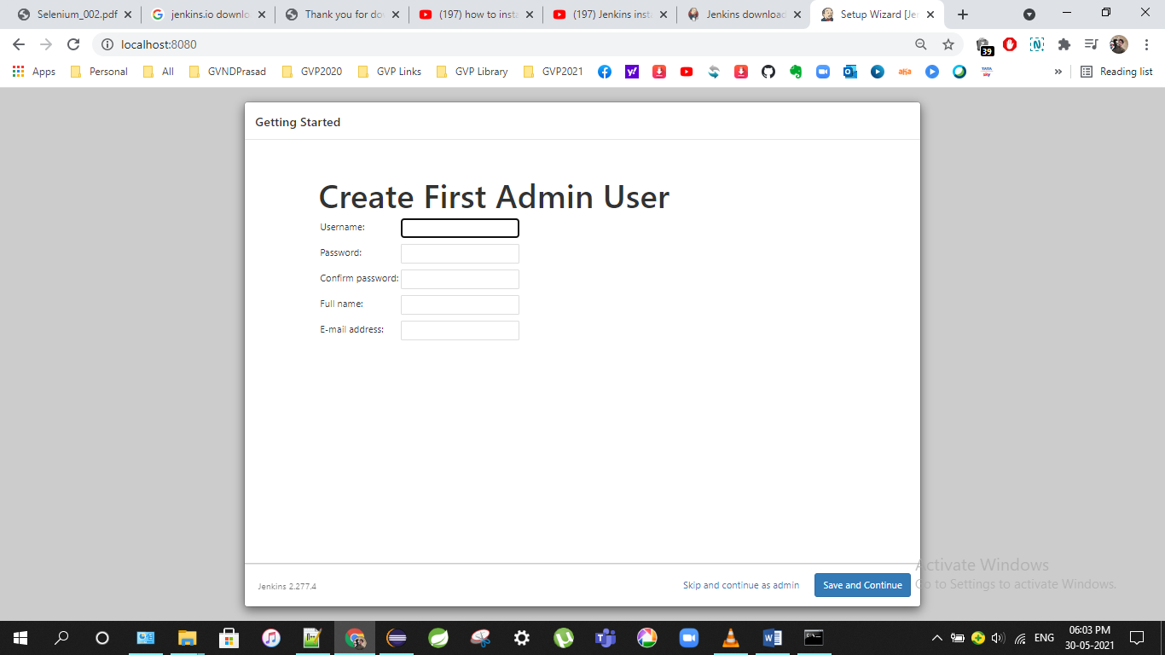

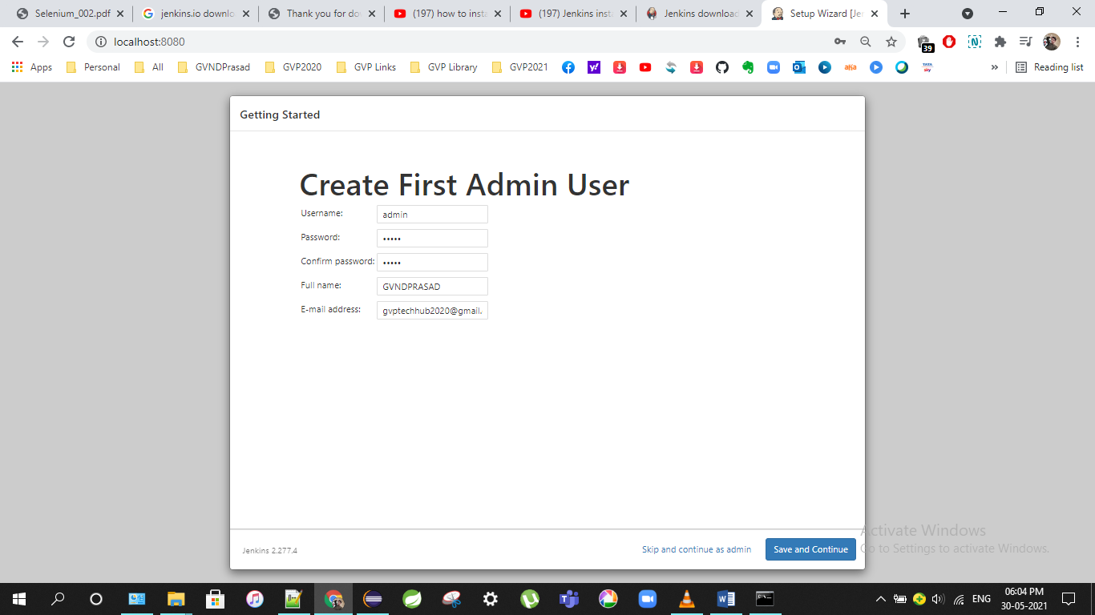

Password: admin

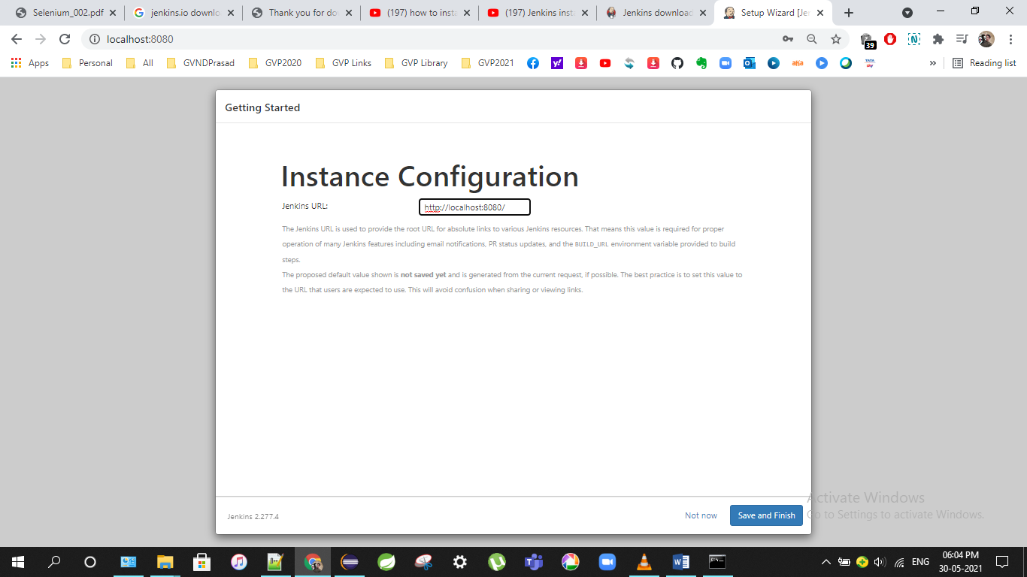

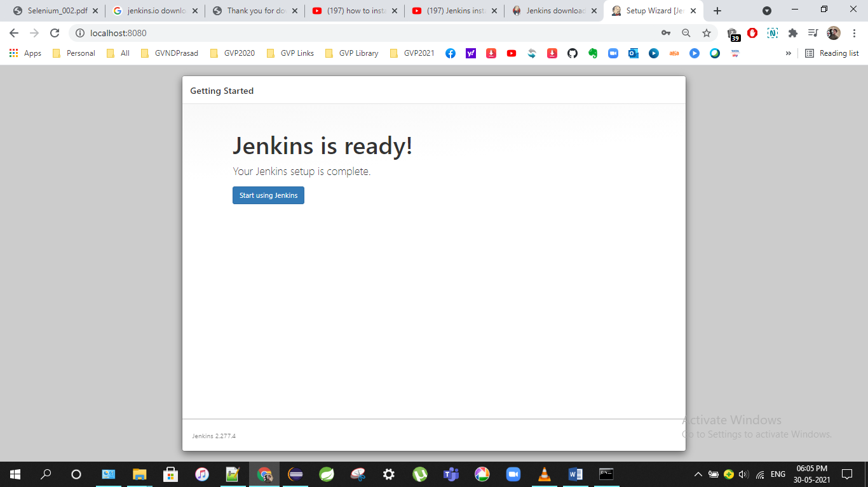

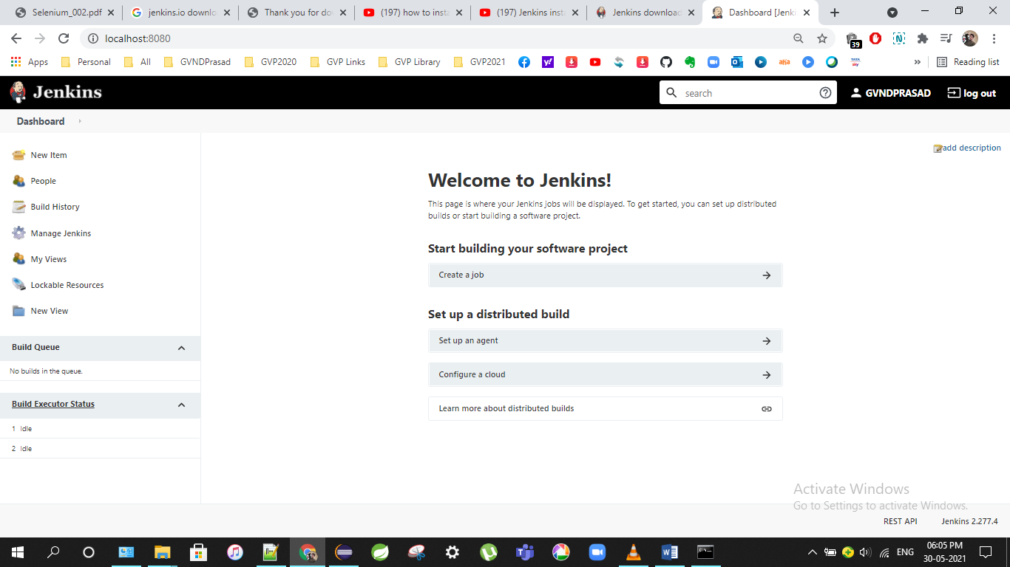

<http://localhost:8080/login?from=%2F>

UserName: admin

Password: admin

Port No: 8080

How may I build & deploy .war/.ear file in jenkins with tomcat server and Github?

<https://www.youtube.com/watch?v=6fcoYGqvg6o&ab_channel=AshokIT>

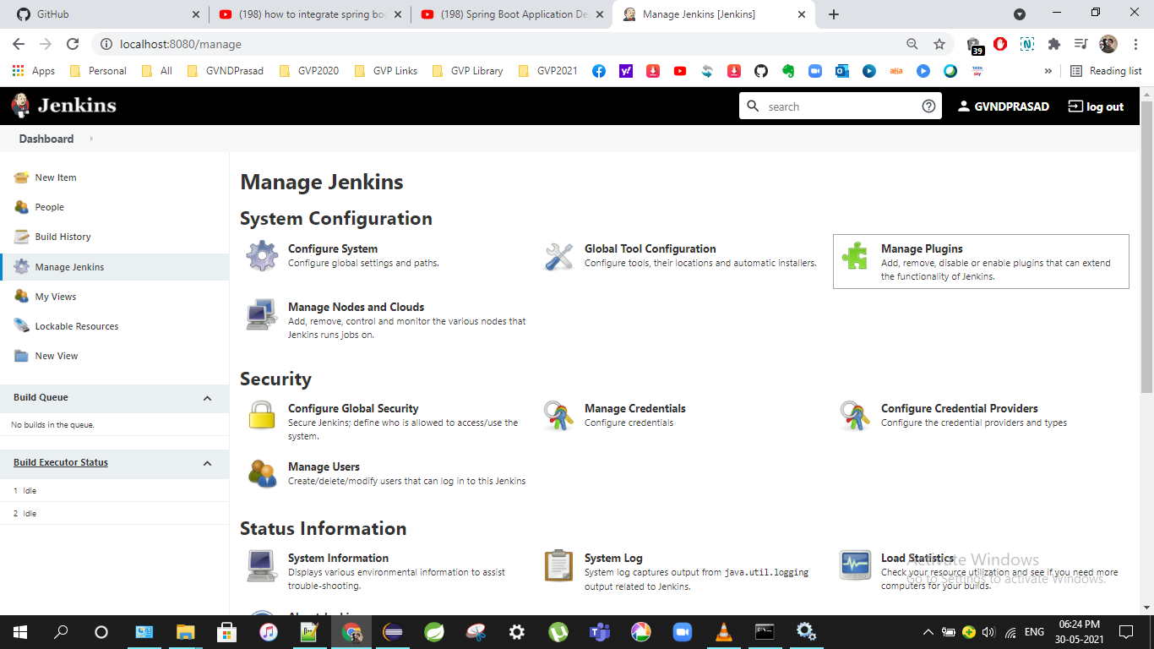

Click on Manage Plug-ins

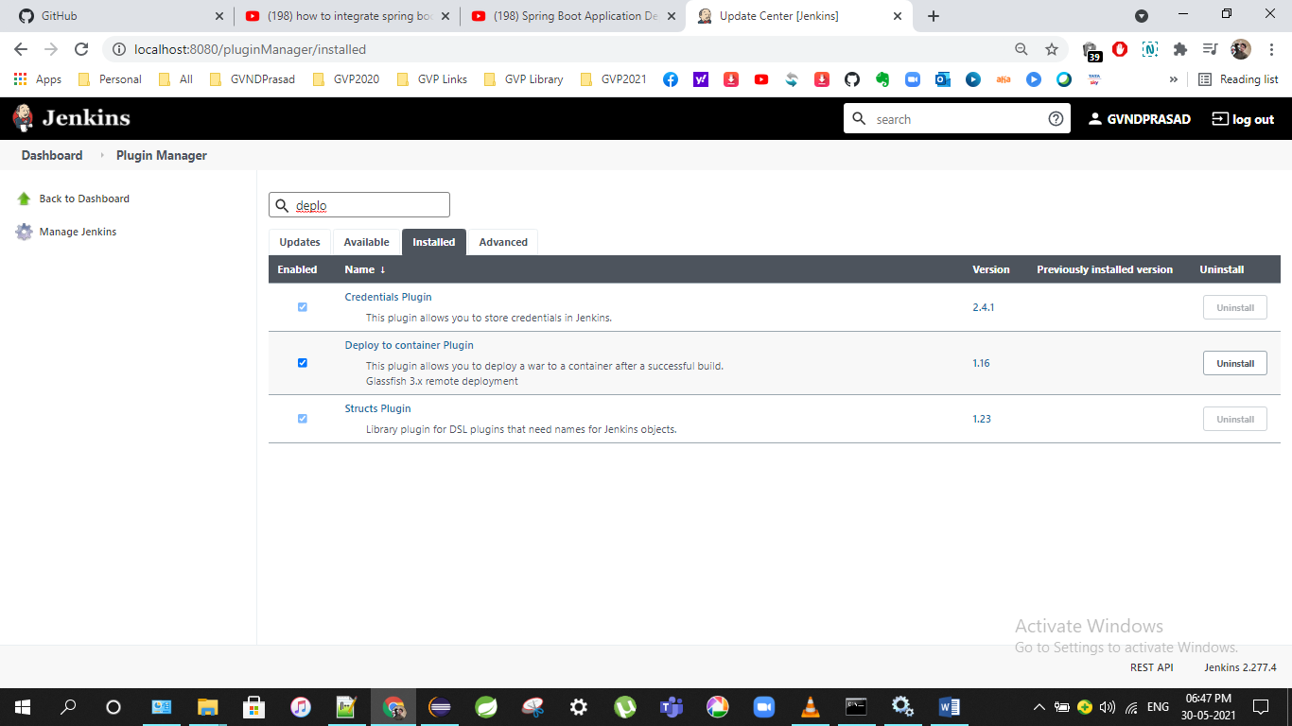

Required: Apache Tomcat, Github,Jenkins,Deploy to container Plug-In

How may I change port number in Jenkins?

https://www.edureka.co/community/71168/how-to-change-the-default-jenkins-port-in-windows

By default 8080.

Now changing to 8081.

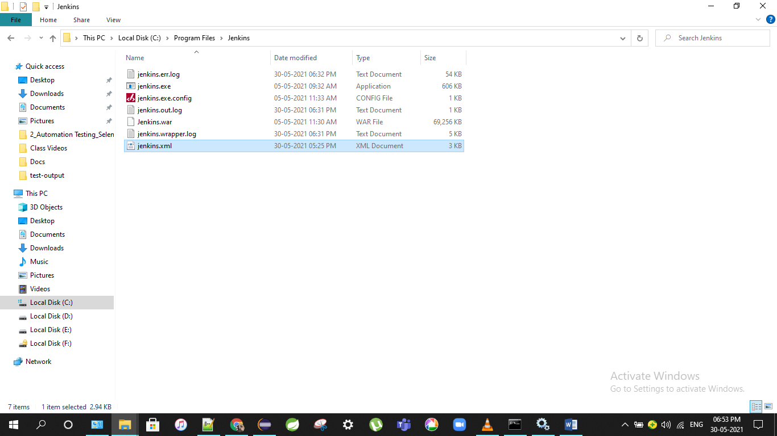

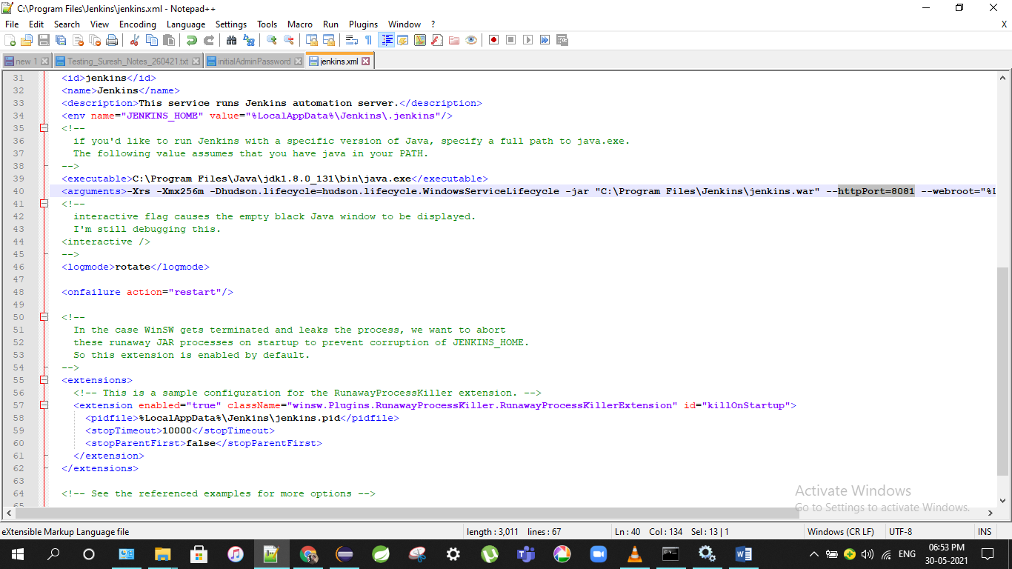

Restart Jenkins

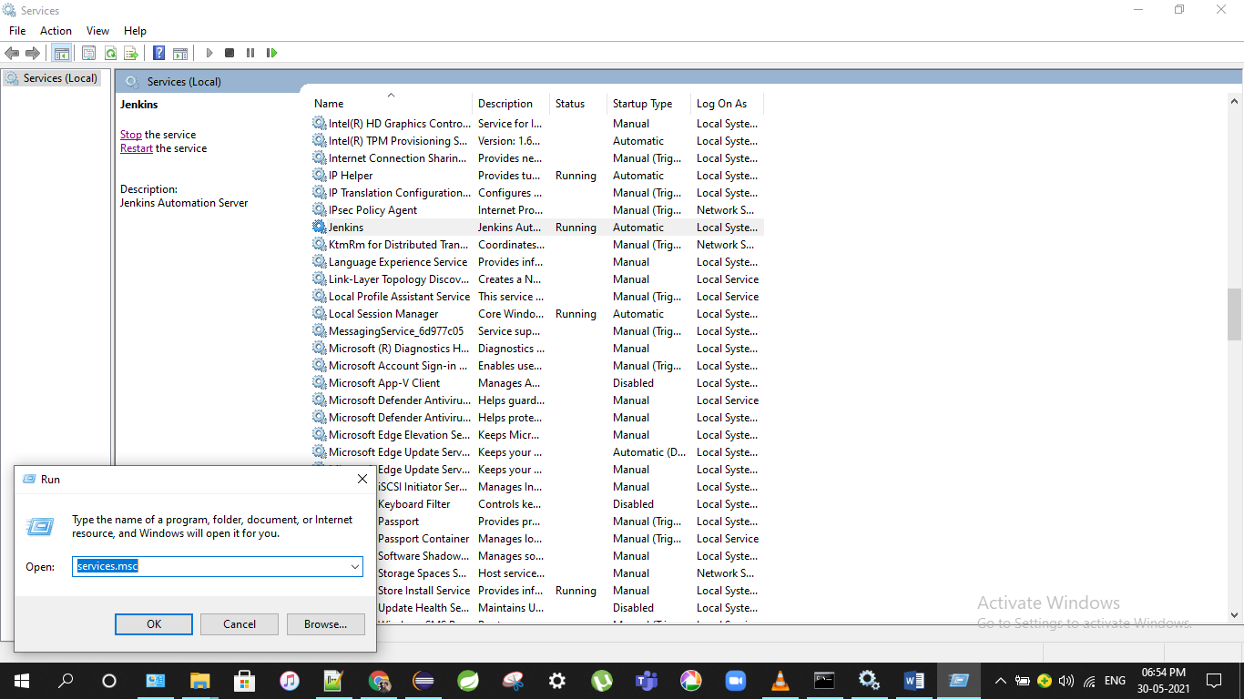

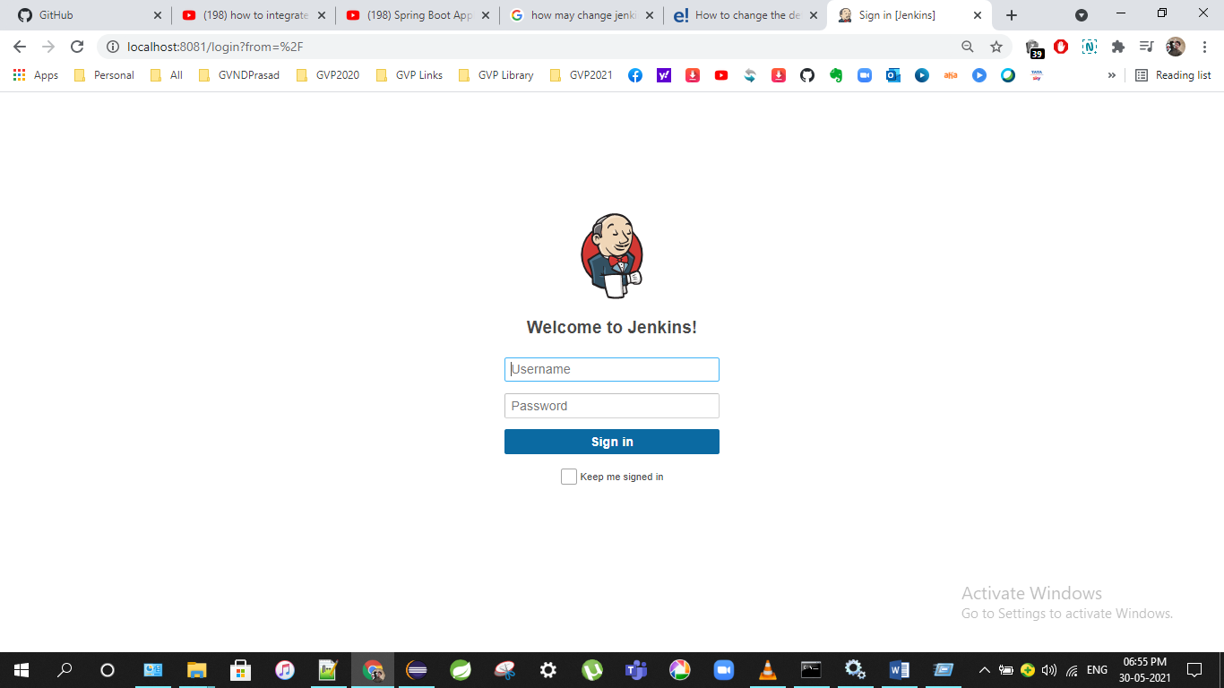

<https://thetechdarts.com/maven-error-jenkins-pipeline-on-windows/>

<https://www.youtube.com/watch?v=RfCWg5ay5B0&ab_channel=CodingMagic>

Need to maintain like this tomcat-users.xml file

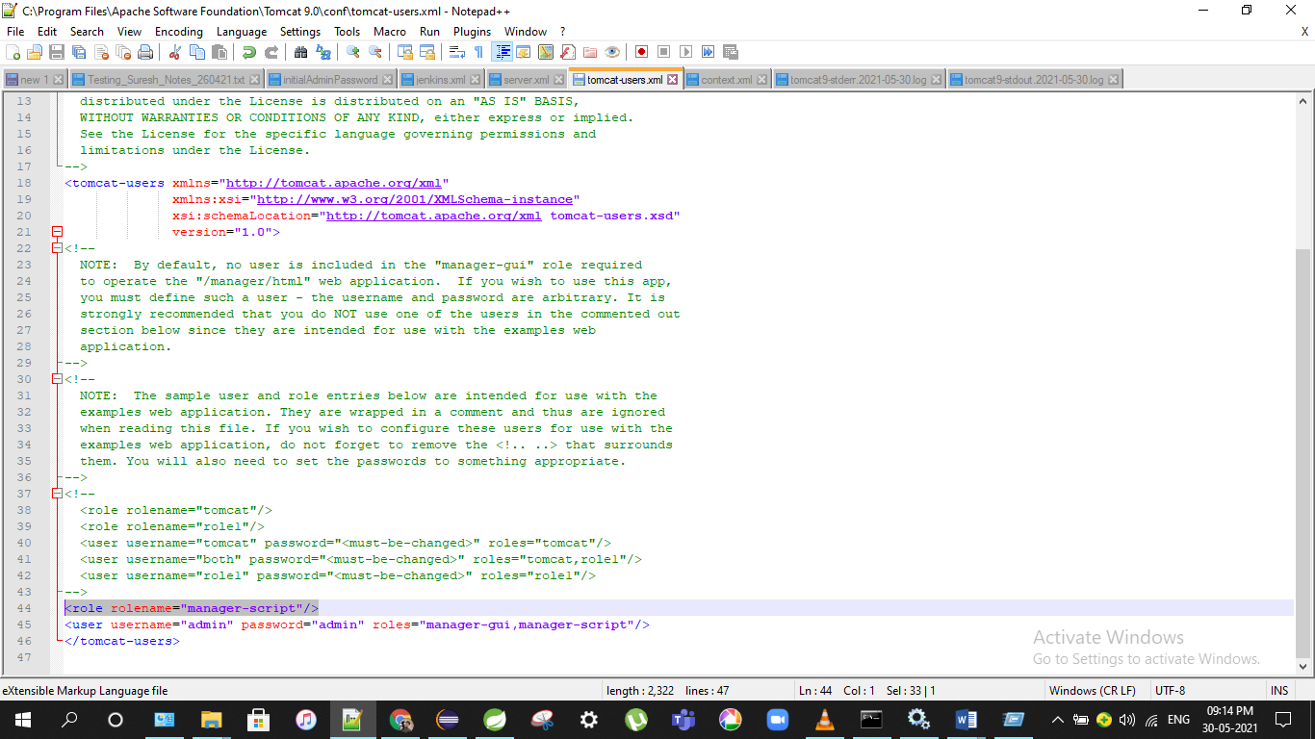

Final Build Success Result:

